Very few constraints

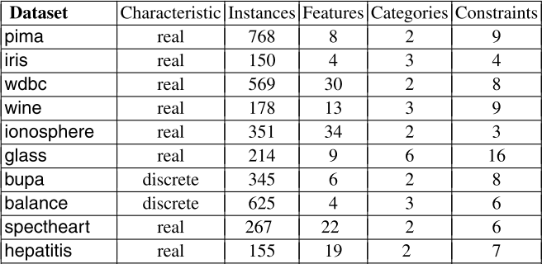

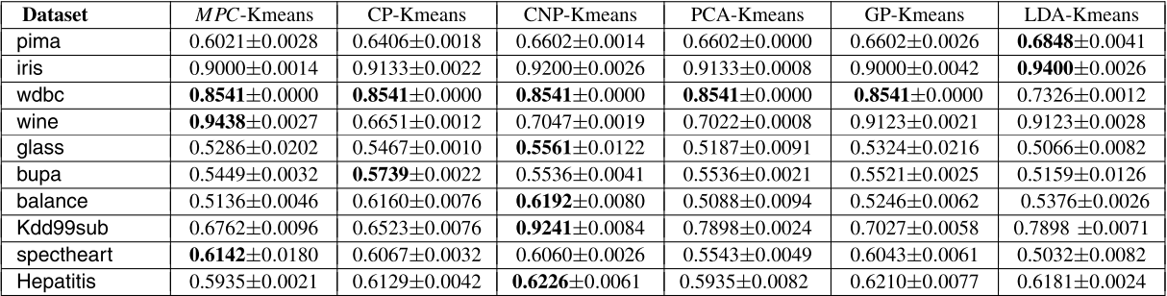
APD+QDA | APD+LS
0.6391±0.0088 | OOM
0.6133±0.0430 | 0.8687
0.7976±0.0300 | OOM
0.6413±0.0156 | 0.5729
0.4610±0.0127 | 0.9109
0.5540±0.0045 | 0.3785
0.4956±0.0129 | 0.5884
- | -
0.6250±0.0165 | 0.7378
0.6219±0.0160 | 0.651

